|  |  |  |  |  |
| --- | --- | --- | --- | --- |
|  | EFFECTIVE PERSONAL PRODUCTIVITY®  *Creating a High-Performance Organization* | | | |
| **Effective Personal Productivity**  **Development Schedule**  **September 2025** | | | | |
|  | | | | |
| **Pre-conference Goal Setting** | |  |  |  |
| *Defining the Goal & Tracking* | | Tuesday | September 9 | 9:00 – 11:00 am |
| **Pre-conference Goal Setting** | |  |  |  |
| *Refinement of Goal Tracking* | | Tuesday | September 16 | 9:00 – 11:00 am |
| **Kick Off** | |  |  |  |
| *Introduction to Concepts* | | Tuesday | September 23 | 9:00 – 11:00 am |
| **Goal Planning** | |  |  |  |
| *Developing Goal Planning Sheets* | | Tuesday | October 7 | 9:00 – 11:00 am |
| **Lesson One** | |  |  |  |
| *The Nature of Productivity* | | Tuesday | October 21 | 9:00 – 11:00 am |
| **Lesson Two** | |  |  |  |
| *Productivity Through Goals Achievement* | | Tuesday | November 4 | 9:00 – 11:00 am |
| **Lesson Three & Mid-term Review** | |  |  |  |
| *Increasing Productivity Through Managing Priorities* | | Tuesday | November 18 | 9:00 – 11:00 am |
| **Lesson Four** | |  |  |  |
| *Improving Productivity Through Communication* | | Tuesday | December 2 | 9:00 – 11:00 am |
| **Lesson Five** | |  |  |  |
| *Empowering the Team for Peak Performance* | | Tuesday | December 16 | 9:00 – 11:00 am |
| **Lesson Six** | |  |  |  |
| *Increasing Productivity of the Team* | | Tuesday | January 13 | 9:00 – 11:00 am |
| **Participant Graduation Presentations** | |  |  |  |
| *Please invite your mentor* | | Tuesday | January 27 | 9:00 – 11:00 am |
| **Dates are Subject to change** | | | | |

|  |  |
| --- | --- |
|  | EFFECTIVE PERSONAL PRODUCTIVITY®  *Creating a High-Performance Organization* |

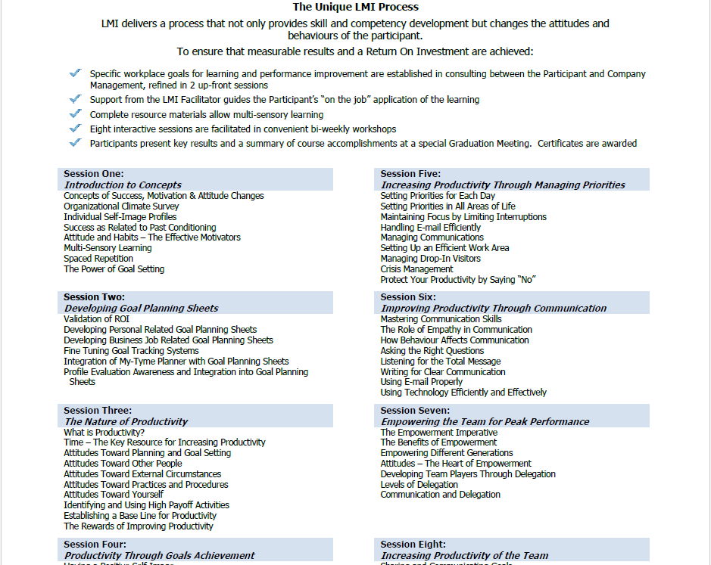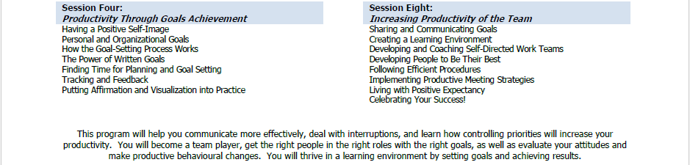

**OTHER LMI DEVELOPMENT TOPICS:** Leadership • Teamwork • Sales • Communication • Supervision • Strategic Management